# Program 1. Create a Simple Calculator for demonstrating the basic arithmetic operations ( + , - , * , / )

MainActivity.java

package com.example.calculator;

import androidx.appcompat.app.AppCompatActivity; import android.os.Bundle;

import android.text.TextUtils; import android.view.View; import android.widget.Button; import android.widget.EditText; import android.widget.TextView;

public class MainActivity extends AppCompatActivity implements View.OnClickListener{ EditText etNum1;

EditText etNum2; Button btnAdd; Button btnSub; Button btnMult; Button btnDiv; TextView tvResult; String oper = ""; @Override

public void onCreate(Bundle savedInstanceState) { super.onCreate(savedInstanceState); setContentView(R.layout.activity_main);

etNum1 = (EditText) findViewById(R.id.etNum1); etNum2 = (EditText) findViewById(R.id.etNum2); btnAdd = (Button) findViewById(R.id.btnAdd); btnSub = (Button) findViewById(R.id.btnSub); btnMult = (Button) findViewById(R.id.btnMult); btnDiv = (Button) findViewById(R.id.btnDiv); btnAdd.setOnClickListener(this); btnSub.setOnClickListener(this); btnMult.setOnClickListener(this); btnDiv.setOnClickListener(this);

}

@Override

public void onClick(View v) { float num1 = 0;

float num2 = 0; float result = 0;

// check if the fields are empty

if (TextUtils.isEmpty(etNum1.getText().toString())

|| TextUtils.isEmpty(etNum2.getText().toString())) { return;

}

// read EditText and fill variables with numbers

num1 = Float.parseFloat(etNum1.getText().toString()); num2 = Float.parseFloat(etNum2.getText().toString()); switch (v.getId()) {

case R.id.btnAdd: oper = "+";

result = num1 + num2; break;

case R.id.btnSub:

oper = "-";

result = num1 - num2; break;

case R.id.btnMult:

oper = "*";

result = num1 * num2; break;

case R.id.btnDiv:

oper = "/";

result = num1 / num2; break;

default:

break;

}

tvResult.setText(num1 + " " + oper + " " + num2 + " = " + result);

}

}

Activity Main.xml

<?xml version="1.0" encoding="utf-8"?>

<LinearLayout xmlns:android="[http://schemas.android.com/apk/res/android"](http://schemas.android.com/apk/res/android) android:orientation="vertical" android:layout_width="fill_parent" android:layout_height="fill_parent" android:weightSum="1">

<LinearLayout android:layout_width="match_parent" android:layout_height="wrap_content" android:id="@+id/linearLayout1" android:layout_marginLeft="10pt" android:layout_marginRight="10pt" android:layout_marginTop="3pt">

<EditText android:layout_weight="1"

android:layout_height="wrap_content" android:layout_marginRight="5pt" android:id="@+id/etNum1" android:layout_width="match_parent" android:inputType="numberDecimal">

</EditText>

<EditText android:layout_height="wrap_content" android:layout_weight="1" android:layout_marginLeft="5pt" android:id="@+id/etNum2" android:layout_width="match_parent" android:inputType="numberDecimal">

</EditText>

</LinearLayout>

<LinearLayout android:layout_width="match_parent" android:layout_height="wrap_content" android:id="@+id/linearLayout2" android:layout_marginTop="3pt" android:layout_marginLeft="5pt" android:layout_marginRight="5pt">

<Button android:layout_height="wrap_content" android:layout_width="match_parent" android:layout_weight="1" android:text="+" android:textSize="8pt" android:id="@+id/btnAdd">

</Button>

<Button android:layout_height="wrap_content" android:layout_width="match_parent" android:layout_weight="1" android:text="-" android:textSize="8pt" android:id="@+id/btnSub">

</Button>

<Button android:layout_height="wrap_content" android:layout_width="match_parent" android:layout_weight="1" android:text="*" android:textSize="8pt" android:id="@+id/btnMult">

</Button>

<Button android:layout_height="wrap_content" android:layout_width="match_parent" android:layout_weight="1" android:text="/" android:textSize="8pt" android:id="@+id/btnDiv">

</Button>

</LinearLayout>

<TextView android:layout_height="wrap_content" android:layout_width="match_parent" android:layout_marginLeft="5pt" android:layout_marginRight="5pt" android:textSize="12pt" android:layout_marginTop="3pt" android:id="@+id/tvResult" android:gravity="center_horizontal" android:layout_weight="0.07">

</TextView>

</LinearLayout>

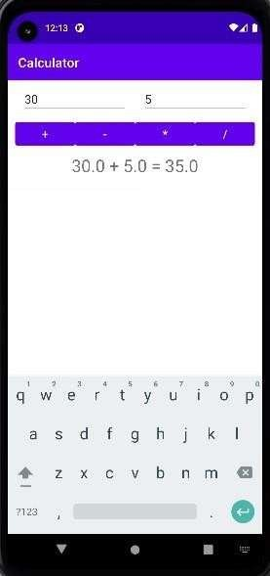 OUTPUT